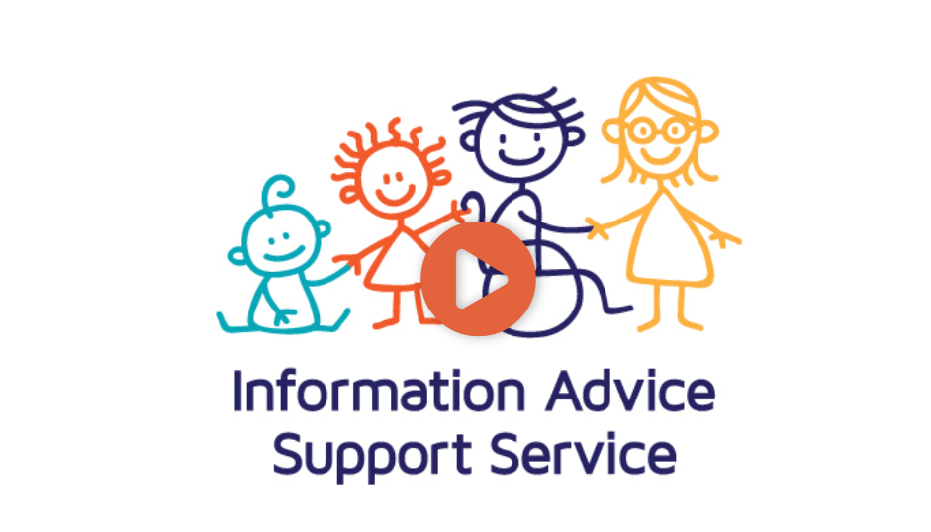
Time stamp | Transcript
00:00 | Start of Video
00:02 | Hello, welcome to Westminster Information Advice and Support Service. We are also known as IASS or SENDIASS for short.
00:13 | We give advice and support to children and young people with Special Educational Needs and/ Disabilities who are aged between 0-25 years old and living in the Westminster area, and their parents and carers.
00:27 | Our advice is free, confidential and impartial. What we mean by impartial is that our advice is based in law, in order for you to be able to make an informed decision about a child or young person’s Educational matters, or Health and Social Care matters that rise as a result of their special educational needs.
00:51 | Our advice is based in SEND law and guidance. All our team members are trained to give accurate legally based information on any educational issues that result from a child or young person’s SEN.
1:08 | “Meet the team”
1:09 | (RC) Hi, I’m Rahmin Chowdhury, service manager. We are a small team who are available to advise you on a wide range of SEND-related matters.
01:18 | Please meet the rest of the team.
01:21 | (MS) Hi, I’m Mahalia Smith. I’m one of the IASS officers. The main focus of my work is in early years, supporting families with children up to 5 years.
01:31 | I work in partnership with the local authority, nurseries and health professionals.
01:35 | If you have concerns about how your child’s additional needs impact on their access to education then please get in touch.
01:44 | Examples of some of the support we offer are what to expect when receiving an initial diagnosis and where to go for support; support in getting your views, wishes and feelings across; and identifying a suitable educational placement.
02:00 | (SB) Hi, I’m Sarah and I joined the team in 2014. I work mostly with families of primary and secondary school aged children, though I also have experience with early years and post-16.
02:14 | I work with professionals like social workers, early years practitioners and SENCos, who refer families to our service for support.
02:24 | Examples of the support we can offer are finding positive ways you can communicate with the local authority and schools, helping you to get extra support for your child, and helping you to understand your child’s Education, Health and Care Plan.
02:39 | (RC) You can find out more about what we have to offer by contacting us or visiting our website.
02:45 | The website has our helpline opening times. We offer face-to-face, virtual, telephone or email appointments.
02:56 | You can get in touch with us by telephone [0207 641 5355], email [iass@wesminster.gov.uk], or website inquiry [wesminsteriass.co.uk]. Deaf users can text us [07816216154], and children and young people can WhatsApp us [07971026703].
3:05 | You will find these details on our website. Thank you.
3:12 | End of video

