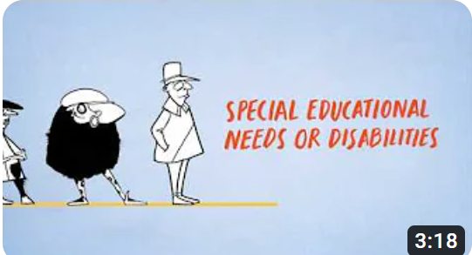
Time stamp | Transcript
00:00 | Start of Video
00:02 | What is an Education, Health and Social Care Plan and who is it for?
00:08 | In 2014 The Children’s and Families Act became law and introduced a new system of support which is relevant to parents and carers of children and young people aged 0-25 who have Special Educational Needs or Disabilities.
00:22 | This means there is a requirement to produce Education, Health and Care Plans or EHCPs using person centred approaches.
00:30 | EHCPs replace Statements of Educational Needs and what were called Learning Difficulty Assessments
00:38 | Two of the key messages featuring in the Children and Families act are that; preparation for adulthood starts in early years, just as it does for other children and all education providers are required to establish and maintain a culture of high expectations so all children and young people can achieve well.
00:59 | This means the goals set should be challenging, not just for the children and young people, but for the education providers too. This requires plans to have a much wider scope than just a statement that generally only addressed the needs of an educational nature.
01:15 | The Plan should wherever possible stretch across four themes ; learning and ‘future employment’, ‘home and independence’, ‘friends, relationships and community’ and ‘health and wellbeing’.
01:28 | Local Authorities must issue a plan for a child or young person who’s needs cannot be met from the expected budget in mainstream schools or settings and for those who attend special schools or specialist colleges
01:43 | EHCPs have seventeen sections labelled A-K. Each section has a different purpose and it is a legally binding document, meaning that certain things in it must happen.
01:38 | The contents of the EHCP are intended to be creative and a shared challenge of all those involved in order to achieve the best possible results and outcomes for the child or young person.
02:08 | In developing a plan the Local Authorities have a duty to take into account section 19 principles and must have regard to; the view, wishes and feelings of the child or young person or parent, the importance of their full participation in decisions, the importance of their being provided with the necessary information and support to participate and the need to support the child or young person to achieve the best possible educational and other outcomes preparing them effectively for adulthood.
02:37 | How can you find out more and access local services and support?
02:44 | You can find out more about the SEN reforms and the Education, Health and Care planning process by visiting the local offer page on your local authority website.
02:53 | Here you will be able to find impartial information advice and support and learn about all the services that are available for you. Parents who require additional support are referred to their local Information Advice, Support Service
03:06 | Further information including useful resources about writing good quality EHC plans can be found at www.councilfordisabledchildren.org.uk
03:17 | End of Video

