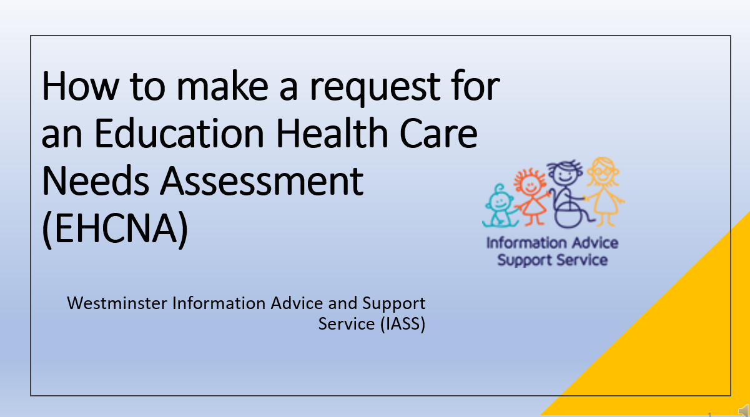
Slide Number | Transcript
00:00 | Start of Video
Slide 1 | NO voice or video  How to make a request for an Education Health Care Needs Assessment  (EHCNA)
Slide 2 | Welcome to our information session. Westminster Information Advice and Support Service (WIASS) is a free service for all parents and carers in Westminster who have children with Special Educational needs and Disabilities (SEND) and for young people aged 16 to 25.
Slide 3 | What is an Education Healthcare need assessment?  An Education, Health and Care (EHC) needs assessment is an assessment of a child or young person’s education, health and care needs. It is the first step to getting an Education, HealthCare plan (EHC plan).  An EHC plan brings your child’s education, health and social care needs into a single, legal document. Your child must have special educational needs to be eligible for a plan.  An EHC plan can result in additional support and funding for a child or young person with special educational needs (SEN).
Slide 4 | You can request an EHC needs assessment. In the special education needs and disabilities code of practice, it sets out the people who have a legal right to ask the local authority to conduct an education, health and care needs assessment for a child or young person aged between 0 to 25.  Schools can make a request for assessment but Parents also have the legal right to ask the local authority to conduct an assessment of their child’s education and healthcare needs. Young people aged 16 to 25 can also make a request on behalf of themselves.
Slide 5 | Your child’s setting will often be able to meet the needs of children through SEN support. However some children or young people will need more intensive level of help that cannot be met from the resources available to schools and other settings. In these circumstances, you or your child’s school or college or nursery could consider asking your local authority for an Education, Health and Care (EHC) needs assessment. This would often be the case when a child or young person has been receiving additional support but is not making expective progress.  For your child to be considered as needing an Education Healthcare Needs Assessment (EHCNA), there are 2 tests that must be met. These are set out in section 36 of the Children and Families Act 2014.  Firstly, that the child or young person has or may have special educational needs and secondly that it may be necessary for special educational provision to be made for the child or young person in accordance with an EHC plan.  You can ask your local authority for a needs assessment if you think your child needs one. Anyone at your child’s school such as your child’s teacher can also ask for an assessment to be carried out. Others who work with your child can also tell the local authority if they think an assessment is needed such as your doctor, health visitor or nursery worker.
Slide 6 | You can make a request for an Education Health and Care needs assessment in writing to the local authority.  There are two ways you can do this, either by downloading the LA request form from the local offer website or using the Westminster Information Advice and Support Service (IASS) template letter which you can download from our website.  You will need to explain why you believe your child has or may have special educational needs and why you believe that they may need special educational provision to be made through an EHC Plan.  When the Local Authority (LA) has received your request, they must reply to you within six weeks to let you know if they have agreed to do the assessments.
Slide 7 | This is the local authority request form which you can download from the Westminster local offer website. The easiest way to find this is by googling Westminster local offer EHCNA request form.
Slide 8 | If you prefer, you can download a template letter from the Westminster Information Advice and Support Service (IASS) website. You should also complete the additional information sheet and the consent form for the Local Authority if you choose to use this template to make your request.
Slide 9 | NO voice or video – Has the following information  What information should I include?  A description of your child or young person’s special educational needs?  What steps the school or educational institution have taken to meet your child’s special educational needs including any additional support, provision or interventions that the school have put in place?  Rates of progress / attainment?  Why you think your child or young person is not making expected progress?  Provision (support / therapies / interventions) that you think that they might need.
Slide 10 | When considering a request for assessment, the Local Authority need to apply a 2-part test which is set out in section 36 of the Children and Families act 2014.  Part 1 of the test states that the child or young person has or may have special educational needs. So the first thing you need to do is provide information about your child’s SEN. You will need to list the SEN already identified by the school or college and attach any supporting evidence. For example, SEND support plans, school reports and include any other needs that you think have not yet been identified by the school or college.  Or you can list the reasons why you feel your child has SEN and any evidence you have to support this, for example school reports, evidence of exclusions, written evidence form any medical or other experts as this may demonstrate that the SEN support is not enough to remove the barriers to your child’s learning and that they may need an Education HealthCare plan in order to access the curriculum.
Slide 11 | The second part of the test is that it may be necessary for special educational provision to be made for the child or young person through the issuing of an EHC Plan.  You should therefore list any reasons you have which show why you think an EHC Plan may be needed to support your child in their education or setting.  It is helpful if you can provide evidence of needs that cannot be met by the school and resources that cannot be provided by the school without a Plan being in place. Some examples include:  - individual support beyond that which a mainstream school can be reasonably expected to provide  - therapies from external professionals or specialists  - Specialist equipment  - And evidence that your child is not making the expected progress despite receiving some support at school/college  This 2-part test that we have just covered in the last 2 slides is the only test to be applied under the law. It would be unlawful for the Local Authority to apply a higher threshold for agreeing to carry out an EHC Needs Assessment.
Slide 12 | To support your request you should include any relevant professional assessments and reports which could include the following:  -SEN Support plans from nursery, school or college  -Medical or Diagnosis letters  -Speech and language therapy or Occupational Therapy  -Physiotherapy or your child’s Paediatrician  -Educational Psychology, Child adolescent mental health psychology  You also may have other reports or assessments that are not listed here.
Slide 13 | Once you have completed your Education Health Care Needs Assessment request form, have a read through to check you have provided the necessary information.  You will then need to complete the consent form that can be found at the bottom of your request letter.  You will also need to provide a proof of address – this could be a bank statement, utility or council tax letter that shows your current address.  Make sure you have attached any Professional reports and letters that contain information about your child’s needs.  You are now ready to submit your request to the SEN Service by emailing it to sen@rbkc.gov.uk  The Local Authority should confirm the receipt of your request and when you receive this, this counts as Day 1 of the Education Health Care process.
Slide 14 | Once the receive and confirm that they have request, the local authority has up to 6 weeks to decide whether to carry out an assessment.  During this time thy will gather information from you and your child or that young person and the school or other setting.  If they decide to carry out the assessment they will contact you within 6 weeks. The local authority then needs to provide you with information to help you understand the process and make sure you are properly involved in the decisions that affect your child. The assessment includes talking to you and your child to find out what support you think your child needs and what aspirations you and your child have for his or her future. Our service can support you with this.  The assessment also includes seeking information and views from people working with your child, such as class teachers, doctors, educational psychologists and other health professionals.
Slide 15 | If the Local authority decides not to carry out an Education Health Care Needs Assessment, they will let you know within 6 weeks of you having submitted your request. They need to inform you of how they reached their decision. For example, there may not be enough information about your child’s Special Educational Needs SEN) or they may feel that the educational setting is able to meet your child within their existing resources.  The Local Authority is expected to help you find other ways that your child can be supported in their school or other setting and should offer a Next SEN support.  If you are unhappy with the Local Authorities decision and do not feel further options proposed are going to help, you do have the right to appeal the decision. You will receive information on how to do this in the LA’s decision letter. Our service can also provide you with information on the Appeals process.
Slide 16 | Our service can help in a number of ways:  - We can offer you a telephone appointment to explain the Education Health Care Needs Assessment process and help you to understand how to complete the forms.  - We can give you advice on the kind of evidence you need to the local authority. For example, your child’s SEN support plan, any documents from the school or college, reports and assessments by healthcare professionals and any hospitals or GP medical letters.  Please do note that we ask parents to ensure they’ve read through all supporting documents and have clear idea of what your child’s difficulties are. As we are unable to allocate time to reading and interpreting reports for an education health care needs assessment request.  Once you have gathered all your information and evidence and as much as you can, we can arrange a further appointment to help you look at your request and provide feedback before you send it to SEN Team. Please note, that parents have to send the request letter and supporting documents to the SEN department themselves. We are unable to do that on your behalf  This is now the end of the session.
 | End of slide show

