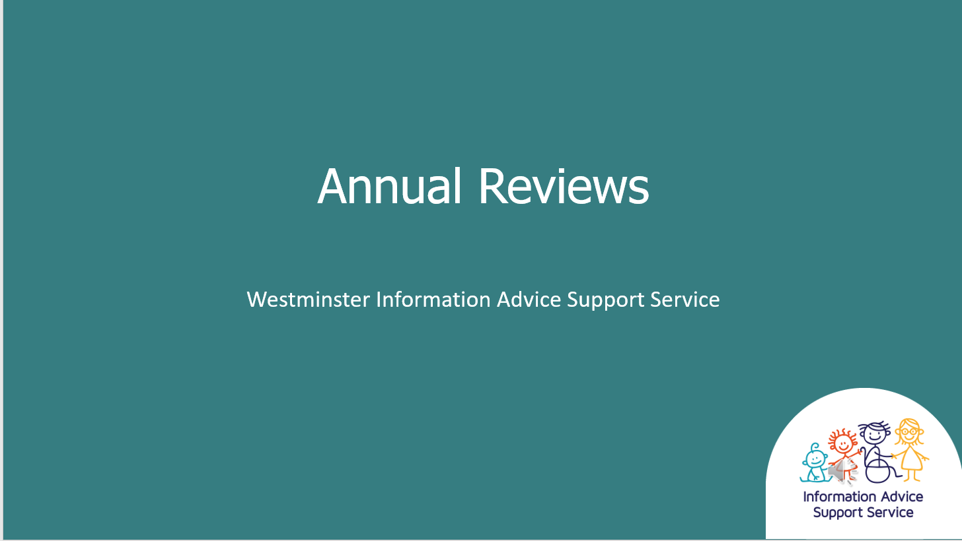
Slide Number | Transcript
00:00 | Start of Video
Slide 1 | Hello and welcome to our presentation on Annual Reviews
Slide 2 | This presentation will cover ‘What is an Annual Review’, ‘the law and guidance on Annual Reviews’, What you can expect to happen during the Annual Review process, Preparing for Annual Reviews from Year 9 onwards
Slide 3 | What is an Annual Review? If you child has an Education, Health and Care Plan the Local Authority must review it at least once a year or every 3-6 months if the child is under 5. This process is called an Annual Review and it is used to Review their progress, Make sure the EHC plan is up to date and help to meet their outcomes. It is the Local Authorities duty to make sure the review process is completed and it is important that you and your child are actively involved. The EHC plan MUST be reviewed every 12 months, from the first date that the first plan was issued or within 12 months of the last Annual Review. If there are significant changes to your child’s needs, for example if your child is at risk of exclusion or the school is saying it cannot meet your child’s needs an Annual Review may be carried out earlier. This is sometimes called an Early Review.
Slide 4 | The SEND Code of Practice details the legal requirements that must be followed without exception. It says Reviews must focus on the child or young person’s progress towards achieving the outcomes specified in the EHC plan. The review must also consider whether these outcomes and supporting targets remain appropriate. It also says Reviews must be undertaken in partnership with the child and their parent or the young person, and must take account of their views, wishes and feelings
Slide 5 | The Annual Review is broken down into 5 legal steps that must be followed. Although the Local Authority is responsible for the Annual Review process it will pass on the responsibility of certain steps to the Headteacher of the education setting. Step 1 - The LA Informs the education setting ( if your child is not in education, the LA must organise the meeting). Step 2: The Headteacher/ Senco Obtains written information and advice from: You and your child/Young person, Senco, Health and Social care professionals/any other professionals working with your child. This information should provide details about your child’s progress and should include whether the support your child is getting is meeting their needs. Some EHC plans may specify the time for professionals to contribute to Annual Review reports and attendance at meetings.
Slide 6 | Organising the Annual Review meeting. Your child’s education setting is responsible for organising and holding the Annual Review meeting. If your child is not in an education setting the Local Authority will usually organise this. Your child’s education setting must invite the same people it has sought information and advice from previously. Other people involved in supporting your child can also be invited, for example, a teaching assistant or a specialist teacher. Everyone invited to the Annual Review must be given 2 weeks notice prior to the meeting date and must also receive the written information and advice gathered at least 2 weeks before the meeting date. If you do not receive this information 2 weeks before the meeting you can ask for the meeting to be changed to a later date.
Slide 7 | The aim of this meeting is to gather opinions on how your child is being supported. You and your child’s wishes, views and opinions are essential and should be at the centre of this process. The Headteacher or Senco should make notes during the meeting and record yours and your child’s views. During the meeting the special educational provision made for your child or young person should be reviewed to ensure it is still being effective. The health and social care provision made for your child or young person should also be reviewed to ensure good progress for all outcomes. Outcomes are the changes expected as a result of the interventions put in place for your child, and should always enable a child or young person to move towards their long term wishes and ambitions. The focus of the meeting should also consider the appropriateness of the plan in the light of the progress made in the previous year and whether changes are required, including any changes to outcomes, enhanced provisions, change of education setting or establishment or whether the EHC plan should be discontinued. This meeting should also be used to review any interim goals and to set new goals for the year ahead.
Slide 8 | What to expect after the Annual review meeting. The headteacher or Senco must write up and send out an Annual Review report to all who attended the meeting. This report should give clear recommendations on any changes to the Education Health Care Plan where this is appropriate. The Local Authority will look at the information on the Annual Review report and review the Education Health Care Plan. Within 4 weeks of the meeting must write to parents to confirm whether to: Keep the EHC Plan as it is, amend the EHC Plan or Cease to maintain the EHC plan. If the decision is to amend the plan the Local Authority must send a copy to the Education Health Care Plan to the parents or young person with the notice of proposed amendments and include any evidence supporting the amendments. They must also inform the parents or young person of their rights to make representations of the contents of the Education Health Care Plan and to request a particular school or institution. You will be given 15 days to comment on the amendments and provide your views. If the Local Authority decide to make changes to the plan they must issue you with an amended plan within 8 weeks of the meeting. If the Local Authority decide not to amend or cease to maintain the plan they must notify you by letter and include information about your right to appeal this decision. It is important to take note that the whole process should take no longer than 12 weeks.
Slide 9 | As mentioned Information or advice reports about your child’s progress must be given to you at least 2 weeks before the meeting takes place. This will give you time to read through the report and think about any questions you may want to ask in the meeting. Things to consider: Is the education setting still suitable in meeting your child’s needs?  What provision you think is helping your child. Do they need more/different types of support?  Any changes to Section A? It is really important that Section A is reviewed as out of date information about your child should be updated especially when you are approaching a phase transfer review  Any areas of concern?  Any further information you think needs to be included in the EHC plan?
Slide 10 | Children with an Education Health Care Plan, it is an requirement in the SEND code of practice. It is required that the plan is reviewed and amended within plenty of time before a child moves between key phases of education. Key phase transfers from early years to primary school, primary to secondary and secondary to a post 16 institution. For moves between post 16 placements amended plans must be issued at least 5 months before the placement is due to take effect.
Slide 11 | Transfer between phases of education : Early Years. The code of practice states An EHC plan must be reviewed and amended in sufficient time prior to a child or young person moving between key phases of education, to allow for planning for and, where necessary, commissioning of support and provision at the new institution.  Local authorities should consider reviewing EHC plans at least every 3-6 months for children under 5  You must be fully consulted of any proposed changes to your child’s plan and made aware of your right to appeal  A review and any amendments of the plan must be completed by 15th February in the calendar year of transfer
Slide 12 | Transfer between phases of education – Primary to Secondary.  For children with an EHC Plan. You will not apply for secondary school through the general admission process but with the local authority SEN team. It is important that everyone is satisfied that the school you are asking for can meet your child’s needs before the school is named in section I of your child’s EHC Plan. There are two opportunities for you to make a request for your child’s secondary school. The first of these is at the phase transfer review usually held during year 5 to ensure it meets the 15th February deadline in the year your child transfers school. You can let your Local Authority know what your choice of secondary school is at this meeting and any transition related outcomes can be added to the EHC Plan at this stage. You will also receive a letter from the Local Authority usually before the end of the summer term when your child is still in year 5. This is called the school preferences form. You must complete this form and sent it back to the local authority promptly. If you don’t will assume you’re not making a request for a specific school and they will name one for you in the final amended plan. Even if you discussed secondary schools at the review you have to complete this form and return it by the Local Authority deadline. The Local Authority must consult with the school or schools requested. This is a requirement under the Children and Families Act and the SEND code of practice. Once they have completed this consultation and the school has responded the Local Authority must then update the plan and state in Section I which school your child will be attending from September. It is a good idea to start attending open days at secondary schools during the autumn term of year 5 so you are already well informed about the choices.
Slide 13 | Preparing for Adulthood: From Year 9 onwards. The SEND code of practice says that the Annual Reviews for children in year 9 and beyond must include a focus on preparing or adulthood, including employment, independent living and participation in community and society. Planning must be centred round the individual and explore the child’s or young person aspirations and abilities, what they want to do when they leave post 16 education or training and the support they need to achieve their ambition.
Slide 14 | Preparing for Adulthood in the Annual Review. As your young person develops they should be involved more closely in the decisions on their own future. The focus should be around options for the next stage of their education. These reviews should also include support to prepare for independent living, including exploring decisions young people want to take for themselves, including where they want to live in the future and who they want to live with and what support they need. Discussions should also take place around how your young person is to be supported in society including, how to find out about social and community activities and support in developing and maintaining friendships and relationships. Young people should be supported in understanding which health professionals work with them as adults. Representatives from post 16 organisations can be invited to these meetings. If the plan is likely to be ceased within 12 months, for example if they young person is leaving formal education. The review should focus on a smooth transition for the next stage in the young person’s life.
Slide 15 | To find further information about the Annual Review process you can read a fact sheet about Annual Reviews, find further information on our website. You can contact the bi-borough SEN service and ask to speak to your child’s SEN co-ordinator. You can also speak with the SENCO at your child’s school.  IPSEA have a really useful checklist setting out the steps and timescales of the Annual Review Process and the SEND code of practice has useful information in chapter 9.
Slide 16 | Thank you for watching this information session for more information and advice please look at our website where you can also find out contact details.

