Keeping what you say private

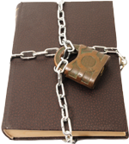When you talk to us we will not tell other people what you said. We will keep it private.

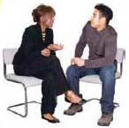

Sometimes we may think it is a good idea to talk to other people about what you tell us, like your parents, teachers or doctors.



We will always ask you if this is ok first. You can say yes or no.

There are a few times when we will have to tell someone else what you said:

  
We sometimes tell our managers so they can check that we are doing a good job.

We will write information about our meetings on our computers.  
  
Only people we work with will see this information.



We will also have to tell someone if we are worried that someone is being hurt or might be hurt.

If this happens, then we will talk to you about it first.

If you need more information, please contact:   
Westminster Information Advice Support Service   
1st Floor, 215 Lisson Grove LONDON NW8 8LF  
Tel: 020 7641 5355   
Email: [iass@westminster.gov.uk](mailto:iass@westminster.gov.uk)  
Website: westminsteriass.co.uk