Impartiality – we will be fair and not take sides
 | Our service is impartial. This means we will not tell you what to do. We will not take sides. We will give you the information and support you need to make your own choices.
 | We will tell you about laws. Laws are the rules that everybody in the country must follow
 | We will tell you about your rights. Rights are things that should happen for everyone
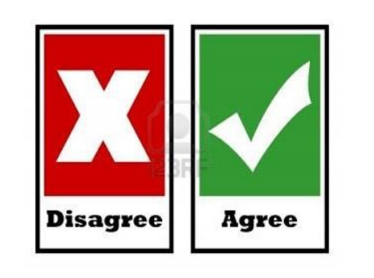 | You can choose what you would like to do. You will be able to trust that IASS is separate from other groups like the council or health services
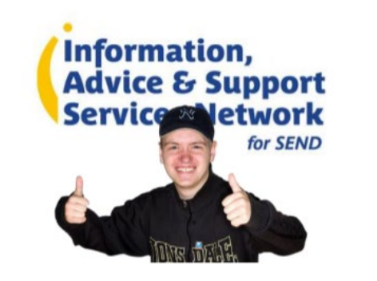 | We have to follow a national set of Minimum Standards. Standards are things that you can expect to happen. Click here
 | If you are not happy with our support then please tell us how we can make it better

