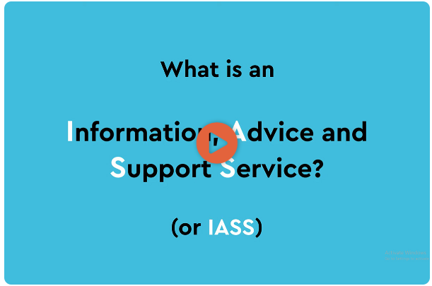

Time stamp | Transcript
00:00 | Start of Video
00:02 | What is an Information Advice Support Service? (Or IASS)
00:06 | IAS services provide; information, Advice and support to children and young people with Special Educational Needs or Disabilities and their parents.
00:22 | The information, advice and support IAS services provide can be about, Health, Social care and Education.
00:31 | The service will make sure you understand what support and services you are entitled to and how to access it.
00:41 | Children and young people with SEND can contact or visit their services independently or through their parents.
00:50 | IAS services are statutory, this means that every local authority in the country has to have one.
01:00 | This is because being able to have free information, advice and support is a legal right for children and young people with special educational needs and/ or disabilities, and their parents.
01:15 | The service is free and confidential, meaning unless someone is worried about your safety, anything you say to someone who works for the service will not be shared with anyone outside the service.
01:29 | The service in impartial, meaning they do not take anyone’s side, they just stick to the fact.
01:38 | IAS services must do certain things and work in a certain way to meet strict standards.
01:46 | These are known as the minimum standards.
01:51 | These animations are about these minimum standards and will help you understand more about information, advice and support services.
02:00 | What they do? Why they do it? and how you can complain if they are not doing it?
02:10 | TEXT - Information Advice & Support Service Network  Council for Disabled children  National Children’s Bureau – part of the family  https://councilfordisabledchildren.org.uk/information-adviceandsupportservicesnetwork.
02:18 | End of Video

