What they are/how they can help?
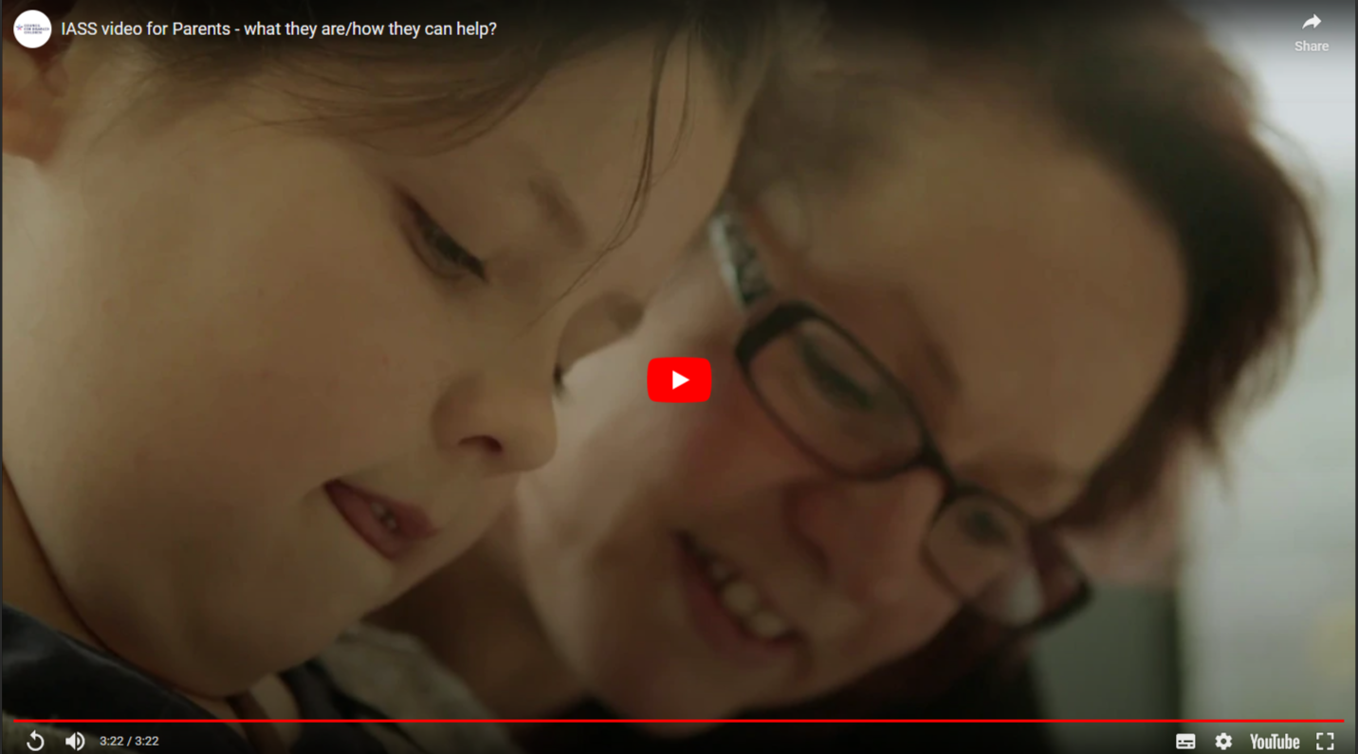
Timestamp | Speaker | Transcript
00:00 |  | Start of Video
00:02 | Sarah - Parent | Harry was diagnosed with at the age of 7 with ADHD and the following year, at the age of 8, he was diagnosed with autism.
00:10 | Sarah - Parent | The school he was at, in the end, decided they couldn’t meet Harry’s needs.
00:16 | Carolyn - Parent | Jamie is no longer at school.
00:18 | Carolyn - Parent | He was born blind, and he’s also got some mild learning difficulties as well.
00:27 | Maria - Parent | My son Conor was born with a quite complex heart condition.
00:30 | Maria - Parent | He suffers from quite a lot of anxiety issues, quite major anxieties, due to his ill health.
00:37 | Maria - Parent | He was crumbling inside all the time.
00:40 | Sharon - Parent | When you’ve got a child that’s got additional needs you find you have to speak up more and if you’re not used to doing that, that’s quite hard.
00:48 | Sian – SENDIASS worker | Around the country there are SENDIASS’s – they’re statutory, so every local authority will have a SENDIASS.
00:55 | Margarette – SENDIASS worker | WE support families, parents, carers with young people aged 0-25 with special educational needs and disabilities.
01:04 | Maria - Parent | I think for parents it’s knowing the right people to go to initially because you just don’t know who to go to. You know, we needed that guidance.
01:14 | Maria - Parent | Without any help, to be fair, I don’t know where we would be.
01:20 | Carolyn - Parent | I contacted SENDIASS last year.
01:24 | Carolyn - Parent | The people have been friendly, helpful, supportive and they’re always there to listen.
01:34 | Margarette – SENDIASS worker | We are a confidential service, but we’re also impartial, so we give advice, we don’t take sides.
01:41 | Sian – SENDIASS worker | We’re really there to talk through their options, to listen to what they’ve got to say.
01:46 | Sian – SENDIASS worker | WE can also give information and advice on the law, so what their rights are.
01:54 | Sarah - Parent | I feel that I know the laws now. I know what my child’s rights are, and I will fight for them.
02:02 | Sarah - Parent | It’s great, I do feel so strong now.
02:07 | Sian – SENDIASS worker | A young person or a parent might contact the service, for information on EHC plans, if they’ve got an issue with support at school. It’s really so that they can feel that they can take these issues forward and feel empowered to do something about that.
02:25 | Sharon - Parent | SENDIASS certainly did give me a lot of information and knowledge about my rights as a parent.
02:32 | Sharon - Parent | Its very empowering, and knowing you’ve got that support is really, really crucial.
02:39 | Sarah - Parent | They will support you every step of the way, they take that weight off you.
02:45 | Sarah - Parent | So, it’s been amazing, not just for me but for Harry as well.
02:49 | Sarah - Parent | Harry started school a few weeks ago and the difference in Harry’s behaviour is amazing.
02:56 | Sarah - Parent | I’m a lot calmer, a lot happier. Harry is just doing so well; he is doing amazing at this new school.
03:04 | Sarah - Parent | So, happy child, happy mum, very happy mum.
03:09 | Text | Protective behaviours
03:13 | Text | Information Advice & Support Services Network  NCB – National Children’s Bureau  Council for Disabled Children
03:18 | Text | Thank you to all the young people, families and IAS service staff from Manchester, Rotherham, and Worcestershire who took part and helped make this video possible.
03:22 |  | End of Video

