Translation of IASS BSL Video
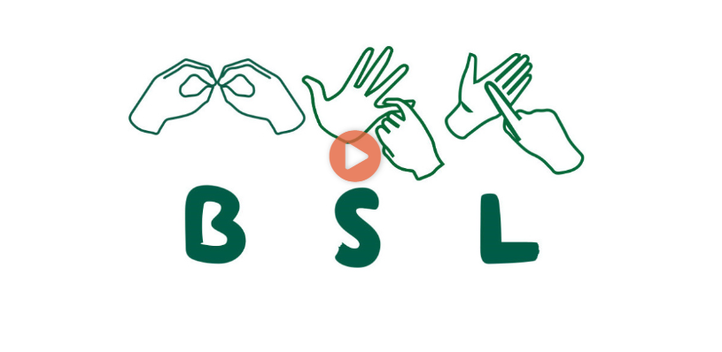
Timestamp | Transcript
00:00 | Start of Video
00:03 | Hello, I’m Rahmin and I am Deaf
00:09 | I am the manager of Westminster Information and Support Service, IASS of SENDIASS for short.
00:23 | Our service is for children and young people from 0-25 years old with SEN or disabilities and their parents and carers, who live in Westminster.
00:53 | Our service offers free, confidential and impartial advice based on SEN law and guidance.
01:13 | Examples are:  - your child is struggling at school and needs further investigation to why this is happening. We can offer advice on how to get an assessment for your child.
01:36 | - We offer support with understanding the EHC process and your child’s Education Health Care Plan (EHCP)
01:53 | - We can offer support in preparation for meetings with a school or the local authority to ensure you feel empowered and able to express yourself.
02:10 | There are many more examples, please have a look at our website.
02:18 | We offer appointments via the phone, email, remote video or face to face. You can contact us by phone, email to text. Young people can contact us via WhatsApp.
02:42 | Thank you, Bye

