Transcript of IASS Animation Video
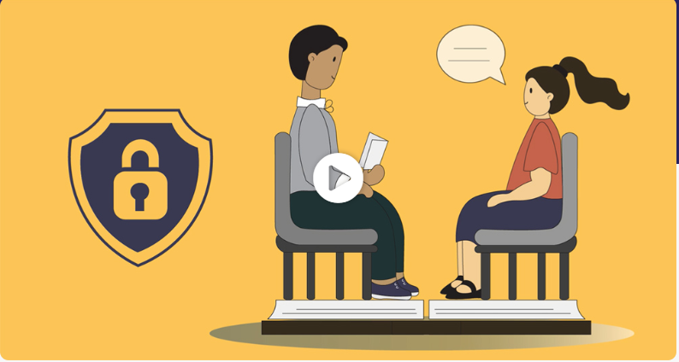
Timestamp | Transcript
00:00 | Westminster Advice and Information Support Service.
00:06 | It is a free confidential and impartial service.
00:11 | Supporting Children and young people with special education needs and disabilities up to the age of 25.
00:20 | We are confidential this means we won’t share or tell anyone what you have told us unless you want us to.
00:28 | We are impartial this means we do not take any sides.
00:33 | We tell you what your legal rights are, talk through your options and listen to what you have to say.
00:40 | You may contact us because you need extra help at school or college, need help understanding the EHC process or understanding your EHC plan or looking at options after you leave secondary school or when you turn 16.
00:57 | Need help finding courses you wish to do and the skills or support you need to get there.
01:03 | Need advice on health and well-being matters including mental health or are looking for things to do in your area.
01:10 | We will offer you advice and support and sometimes direct you to other services that can help.
01:17 | We can empower you to feel confident and have your voice heard.
01:20 | We can support you in meetings with other professionals and we can speak with you in the way you most feel comfortable.
01:28 | You can get in touch with us by phone, email, text, in person.
01:34 | Westminster Information Advice Support Service.
01:39 | City of Westminster.
01:45 | Video Finished

