Education Health Care (EHC) needs assessment
for children in early years or at school

A step-by-step explanation of EHC needs assessment
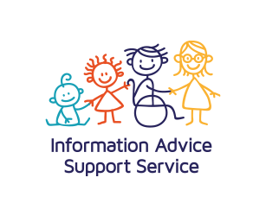

EHC needs assessment for children in early years settings or at school

This information is about Education, Health and Care (EHC) needs assessment, which is sometimes called statutory assessment. It covers:
- children in early years settings
- children of school age.

What is an EHC needs assessment?

An EHC needs assessment is a detailed look at a child’s special educational needs (SEN) and the support he or she may need to learn.
Local authorities are responsible for carrying out EHC needs assessments under the Children and Families Act 2014.

The needs assessment brings together information about:
- what your child can and cannot do
- the special help they need.

It includes information from:
- you
- your child
- the early years’ setting or school
- other professionals who work with or support your child.

The assessment is to see if your child needs an Education, Health and Care plan (EHC plan).

When is an EHC needs assessment necessary?

The school or early years setting can often give your child help through SEN support. This means that the school makes additional or different provision to meet their needs. Sometimes other professionals will give advice or support to help your child learn.
Some children need more intensive and specialist help. If your child does not make progress despite the SEN support an EHC needs assessment might be the next step.

The SEND Code of Practice says:
A local authority must conduct an assessment of education, health and care needs when it considers that it may be necessary for special educational provision to be made for the child or young person in accordance with an EHC plan. (9.3)

The local authority will look at:
- your child’s attainments and rate of progress
- their special educational needs
- what has already been done
- the difference that support has made
- your child’s physical, emotional and social development and health needs.

The SEND Code of Practice says:
In considering whether an EHC needs assessment is necessary, the local authority should consider whether there is evidence that despite the early year provider, school or post-16 institution having taken relevant and purposeful action to identify, assess and meet the special educational needs of the child or young person, the child or young person has not made expected progress. (9.14)

Some children and young people will have needs that clearly require an EHC needs assessment and EHC plan. Once the local authority is aware that this is the case it should start the process without delay.

You can find out more about the criteria that local authorities should follow in the SEND Code of Practice sections 9.3 and 9.14 to 9.16.

Who can ask for an EHC needs assessment?
- parents – by writing to the local authority
- a young person over the age of 16 but under the age of 25
- the early years setting or school, but only after talking with parents first.
It is always a good idea to talk to the school or early years setting before asking for an EHC needs assessment.

The Information Advice Support Service (IASS) can advise you how to make your request. Other people, such as your doctor or a health visitor, can tell the local authority that they think your child needs an assessment.

What happens when the local authority gets a request for an EHC needs assessment?

As soon as the local authority gets a request for an EHC needs assessment they must tell you about it.

The SEND Code of Practice says:
In considering whether an EHC needs assessment is necessary, local authorities should pay particular attention to the views, wishes and feelings of the child and his or her parent, or the young person. (9.12)

The local authority has up to six weeks to decide whether to make a needs assessment. During this time, it may ask you, the school and other professionals for information.

It will look at all the information and must then tell you whether it has decided:
to start the EHC needs assessment immediately or that an EHC needs assessment is not necessary.

What happens if the local authority decides that an EHC needs assessment is not necessary?

The local authority must tell you why it thinks that an EHC needs assessment is not needed. It must also tell you about:
- your right of appeal
- independent disagreement resolution and mediation
- how to get further information, advice or support.

If you disagree with the decision IASS can explain your options to you.

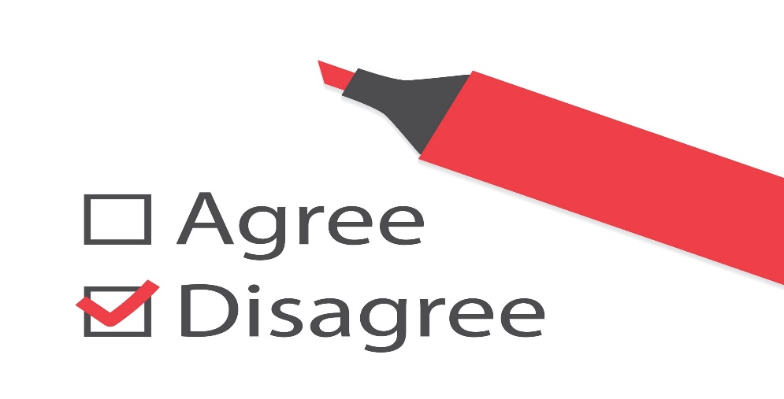

What happens if the EHC needs assessment goes ahead?

The SEND Code of Practice says:
Local authorities must consult the child and the child’s parent or the young person throughout the process of assessment and production of an EHC plan. They should also involve the child as far as possible in this process. The needs of the individual child and young person should sit at the heart of the assessment and planning process. (9.21)

The local authority will write to you to tell you what will happen and ask for your views. Your views and your child’s views are important. IASS can give you information, advice and support to help you with this.

The local authority will ask a few other people for information about your child. This is called ‘advice’ and it should include information about:
- your child’s education, health and care needs
- the desired outcomes for your child
- the special educational, health and care provision that might be required to meet their needs and achieve the desired outcomes.

The local authority must ask for advice and information from:
- parents (or the young person)
- your child’s early years setting or school
- an educational psychologist
- health professionals who work with your child. This might include a paediatrician, speech and language therapist, physiotherapist or occupational therapist.
- social care staff
- anyone else you ask them to contact who may be able to give relevant advice.

If your child has a vision or hearing impairment the local authority must also seek information and advice from a suitably qualified teacher.

The local authority should also try to find out your child’s views. You, the school and other professionals may be able to help with this. If you think your child needs someone to help them, give their views you can ask IASS for more information about this.

You will have the chance to discuss your child with everyone involved in the needs assessment and you will receive a copy of all the reports when the needs assessment is finished.

You can find out more about advice and information for EHC needs assessments in the SEND Code of Practice sections 9.45 – 9.52.

What if some of this advice is already available?

Sometimes advice and information is already available because other professionals have been working with your child.
The SEND Code of Practice says:

The local authority must not seek further advice if such advice has already been provided (for any purpose) and the person providing the advice, the local authority and the child’s parent or the young person are all satisfied that it is sufficient for the assessment process. In making this decision, the local authority and the person providing the advice should ensure the advice remains current. (9.47)

When does the EHC needs assessment end?

Once the local authority has all the information and advice it must decide whether your child needs an Education, Health and Care plan.

An EHC plan is a legal document written by the local authority. It describes the special educational needs that a child or young person has and the help that they will be given to meet them. It also includes the health and care provision that is needed.

Sometimes the local authority will decide that your child has special educational needs that can be met through SEN support. If this is the case the local authority must tell you of its decision within 16 weeks of receiving a request for an EHC needs assessment. The local authority must also tell you about your right of appeal.

If the local authority decides an EHC plan is necessary, they must first write a draft plan, then they will send you the draft EHC plan and copies of the reports so that you can read it all. You should check that everything you think is important has been included and that you agree with the outcomes and the proposed provision. The local authority will also ask you which school you prefer your child to go to.

You have 15 days to make comments, to ask for a meeting, or accept the draft plan.
Note - if you do not reply within 15 days the local authority may assume that you agree with the draft plan.
The last stage is for the local authority to send you the final EHC plan. If you are still unhappy with the plan or cannot agree with the local authority, you have a right to go to mediation and/or to appeal (see below).

If you need help at any stage, you can contact IASS.

How long does all this take?
The local authority receives a request for an EHC needs assessment. The authority must tell parents about this request | This is the start date
The local authority decides whether an EHC needs assessment is needed. The authority must tell parents about its decision | Within six weeks of the start date
The EHC needs assessment takes place | This starts as soon as the decision is made
EITHER
The local authority tells the parents of the decision not to issue an EHC plan | Within 16 weeks of the start date
OR
The local authority sends a draft EHC plan to parents
Parents must respond to the draft EHC plan.  They can:  - agree that the draft is accurate  - ask for changes  - ask for a meeting.  Parents also state a preference for a school or early years setting | Within 15 days of receiving the draft EHC plan
The local authority consults with the school or early years setting | Within 15 days of parents’ response to the draft EHC plan
The local authority issues the final EHC plan | Within 20 weeks of the start date

Sometimes these timescales can be different. See SEND Code of Practice section 9.42.

What if I do not agree with the local authority about the EHC needs assessment or the EHC plan?
At any stage you can ask to talk to a member of the local authority’s staff. This will usually be the person named in the letter from the local authority when they receive a request for an EHC needs assessment.

You also have a right to request independent disagreement resolution and, in some circumstances, mediation. You can find out more about disagreement resolution and mediation on the Local Offer page and in the SEND Code of Practice Chapter 9.

Where can I get more information, advice or support?
You can read about Education, Health and Care needs assessments in the SEND Code of Practice Chapter 9.
The Local Offer includes more information on the local arrangements for EHC needs assessments.

IASS can give you:
- information about EHC needs assessments
- advice and support during the process of assessment
- details of other organisations, support groups and services that may be of help
- information, advice and support about your rights to make a complaint, seek independent disagreement resolution or mediation.

CONTACT US

Call 020 7641 5355
Deaf users 07816 216154

WhatsApp 0797 102 6703

Email iass@westminster.gov.uk

Visit westminsteriass.co.uk
You can find us at
First floor
215 Lisson Grove NW8 8LF

Scan the QR code for more information on our website

We can meet children and young people directly and talk to them about their options.
They can send a text or WhatsApp us on
0797 102 6703

In partnership with

